**SKILL LEARNT: TDD USING JUNIT 5 AND MOCKITO (WEEK 2)**

**EXERCISE 1: SETTING UP JUNIT**

The project name created is JUnit. The package created is tests. Inside tests, the class created is Calculator.java.

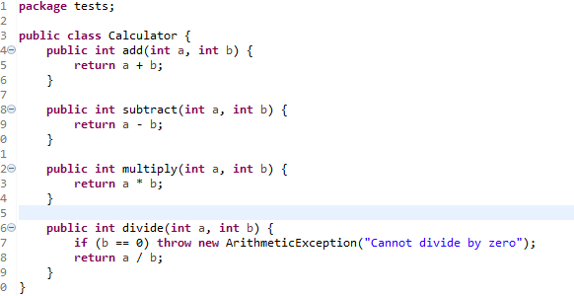

Then a JUnit test case is created by selecting JUnit 4 test and then adding JUnit 4 library to the build path. A CalculatorTest.java Class is created through which the test cases will be checked.

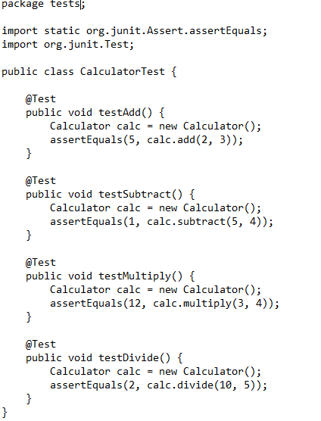

**OUTPUT:**

The test cases passed successfully showing 0 errors.

**EXERCISE 3: ASSERTIONS IN JUNIT**

The project name created is JUnitTesting. Inside that we have a JUnit test case which is created by selecting JUnit 4 test and then adding JUnit 4 library to the build path. A AssertionsTest.java Class is created through which the test cases will be checked. The code for that is:

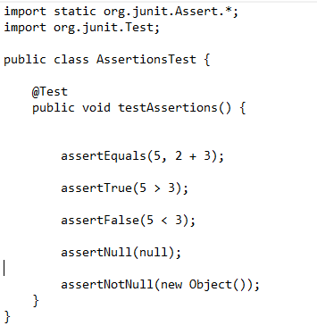

**OUTPUT:**

The test cases passed successfully showing 0 errors.

**EXERCISE 4: ARRANGE-ACT-ASSERT PATTERN, TEXT FIXTURES, SETUP AND TEARDOWN METHOD IN JUNIT**

The project name created is JUnitDemo. The package created is tests. Inside tests, the class created is Calculator.java.

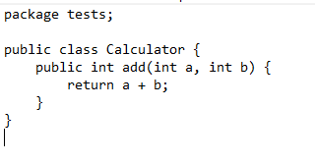

Then a JUnit test case is created by selecting JUnit 4 test and then adding JUnit 4 library to the build path. A CalculatorTest.java Class is created through which the test cases will be checked.

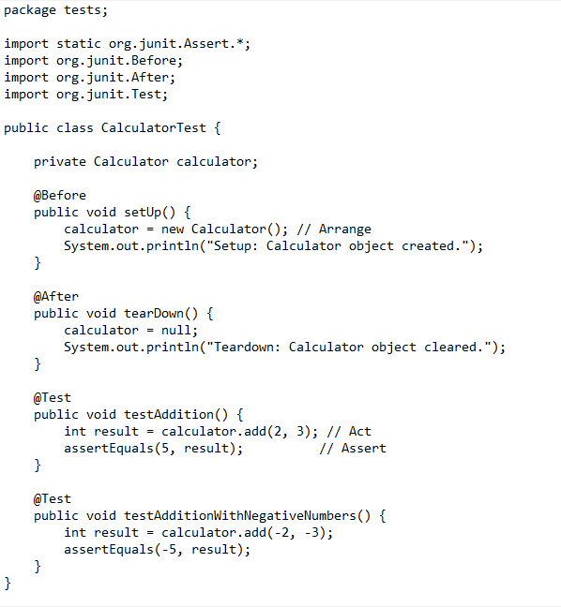

**OUTPUT:**

The test cases ran successfully showing 0 errors.